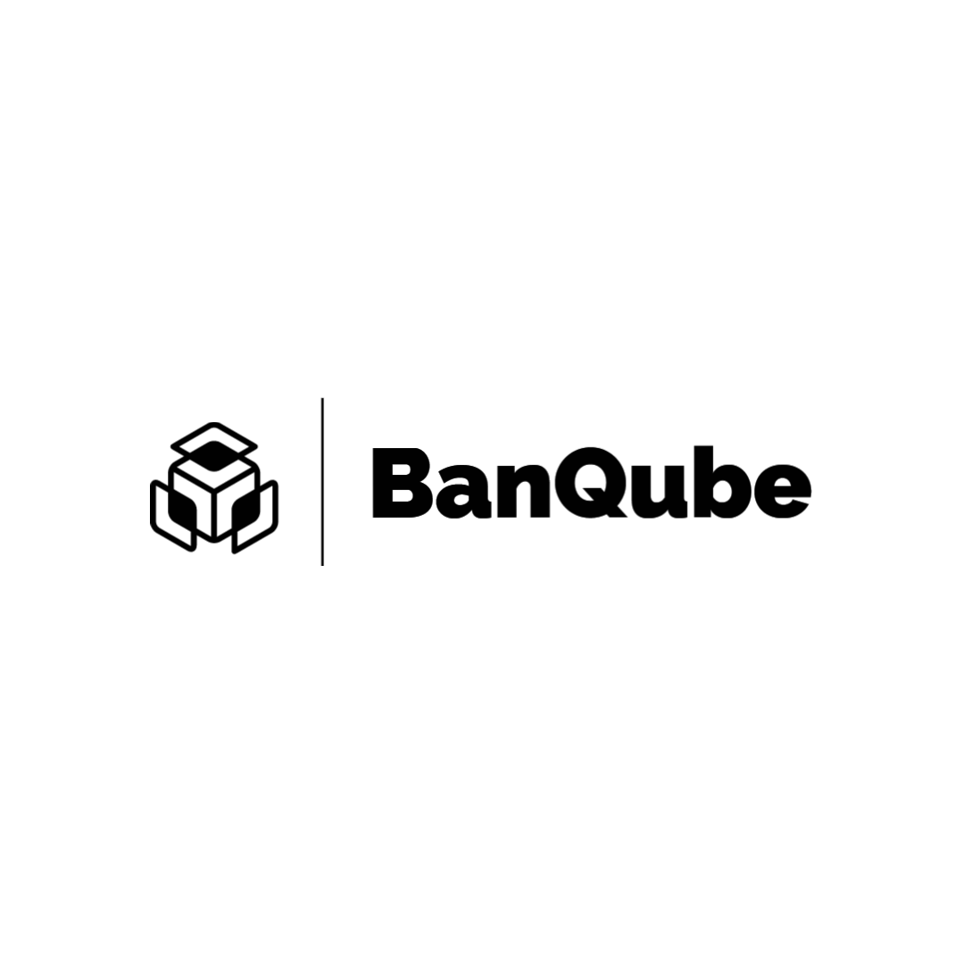

**A PROJECT REPORT**

###### **Submitted by**

| **Akshat Nigam** | 18BCY10010 |
| --- | --- |
| **Alkesh Gupta** | 18BCY10012 |
| **Shreyansh Saxena** | 18BCY10093 |
| **Fardeen Ahmed** | 18BCY10034 |

*in partial fulfillment for*

*the award of the degree of*

**Bachelor of Engineering & Technology**

**SCHOOL OF COMPUTER**

**SCIENCE & ENGINEERING**

**VIT Bhopal University**

**KOTHRI KALAN, SEHORE**

**Madhya Pradesh - 466114**



**March 2022**

**VIT BHOPAL UNIVERSITY, KOTHRI KALAN, SEHORE**

**MADHYA PRADESH – 466114**

**BONAFIDE CERTIFICATE**

Certified that this project report titled **“Secure Banking System using Blockchain Technology”** is the bonafide work of **Akshat Nigam (18BCY10010), Alkesh Gupta (18BCY10012), Shreyansh Saxena(18BCY10093),** and **Fardeen Ahmed (18BCY10034)** who carried out the project work under my supervision. Certified further that to the best of my knowledge the work reported at this time does not form part of any other project/research work based on which a degree or award was conferred on an earlier occasion on this or any other candidate.

| **PROGRAM CHAIR** |  | **PROJECT GUIDE** |
| --- | --- | --- |
| Dr. R. Rakesh |  | Dr. Praveen Lalwani |
| Associate Professor |  | Assistant Professor |
| School of Computer Science & Engineering  VIT BHOPAL UNIVERSITY |  | School of Computer Science & Engineering  VIT BHOPAL UNIVERSITY |

The Capstone Examination is held on 02/04/2022

**ACKNOWLEDGEMENT**

First and foremost I would like to thank the Lord Almighty for His presence and immense blessings throughout the project work.

I wish to express my heartfelt gratitude to Dr. Pushpinder Singh Patheja, Head of the Department, School of Computer Science & Engineering for much of his valuable support and encouragement in carrying out this work.

I would like to thank my internal guide Dr. Praveen Lalwani, for continually guiding and actively participating in my project, giving valuable suggestions to complete the project work.

I would like to thank all the technical and teaching staff of the School of Computer Science & Engineering, who extended directly or indirectly all support.

Last, but not least, I am deeply indebted to my parents who have been the greatest support while I worked day and night for the project to make it a success.

**BanQube | (i)**

**ABSTRACT**

When payment systems were first computerized, the underlying processes were not significantly changed. While records and ledgers have been converted from paper to electronic form, the basic structure of centralized payment systems remained. The Indian banking industry today is struggling with issues such as rising costs of operations, increasing susceptibility to fraudulent attacks on centralized servers, and challenges in ensuring transparency.

We aimed to create a web 3.0 compliant application built on top of a cloud-based architecture hence overcoming the current challenges which the conventional financial systems are facing i.e. lack of transparency, delay in fund settlement, and reducing the chances of fraudulent activities.

**TABLE OF CONTENTS**

|  |  | *Abstract* | **(i)** |
| --- | --- | --- | --- |
|  | **PROJECT DESCRIPTION AND OUTLINE** | | **01-02** |
|  | **1.1** | **Introduction . . . . . . . . . . . . . . . . . . . . . . . . . . . . . . .** | **01** |
|  | **1.2** | **Motivation for the work . . . . . . . . . . . . . . . . . . . . .** | **01** |
|  | **1.3** | **Introduction to the project . . . . . . . . . . . . . . . . . . .** | **01** |
|  | **1.4** | **Problem Statement . . . . . . . . . . . . . . . . . . . . . . . . .** | **02** |
|  | **1.5** | **Objective of the work . . . . . . . . . . . . . . . . . . . . . . .** | **02** |
|  | **1.6** | **Summary . . . . . . . . . . . . . . . . . . . . . . . . . . . . . . . . .** | **02** |
|  | **RELATED WORK INVESTIGATION** | | **03-05** |
|  | **2.1** | **Introduction . . . . . . . . . . . . . . . . . . . . . . . . . . . . . . .** | **03** |
|  | **2.2** | **Existing Work . . . . . . . . . . . . . . . . . . . . . . . . . . . . . .** | **03** |
|  | **2.3** | **Pros and Cons of the conventional financial system** | **04** |
|  | **2.4** | **Issues/Observations from the Investigation . . . . .** | **05** |
|  | **2.5** | **Summary . . . . . . . . . . . . . . . . . . . . . . . . . . . . . . . . .** | **05** |
|  | **REQUIREMENT ARTIFACTS** | | **06** |
|  | **3.1** | **Hardware Requirements . . . . . . . . . . . . . . . . . . . . .** | **06** |
|  | **3.2** | **Software Requirements . . . . . . . . . . . . . . . . . . . . . .** | **06** |
|  | **3.3** | **Specific Project Requirements . . . . . . . . . . . . . . . .** | **06** |
|  | **DESIGN METHODOLOGY AND ITS NOVELTY** | | **07-14** |
|  | **4.1** | **Methodology and Goal . . . . . . . . . . . . . . . . . . . . . .** | **07** |
|  | **4.2** | **Functional Module Design and Analysis . . . . . . .** | **07** |
|  | **4.3** | **Software Architectural Design . . . . . . . . . . . . . . . .** | **08** |
|  | **4.4** | **User Interface Designs . . . . . . . . . . . . . . . . . . . . . . .** | **09** |
|  | **TECHNICAL IMPLEMENTATION & ANALYSIS** | | **15-19** |
|  | **5.1** | **Outline . . . . . . . . . . . . . . . . . . . . . . . . . . . . . . . . . . .** | **15** |
|  | **5.2** | **Technical Coding & Code Solutions . . . . . . . . . . . .** | **15** |
|  | **5.3** | **Prototype Submission . . . . . . . . . . . . . . . . . . . . . . .** | **16** |
|  | **5.4** | **Test and Validation . . . . . . . . . . . . . . . . . . . . . . . . .** | **17** |
|  | **PROJECT OUTCOME AND APPLICABILITY** | | **20-21** |
|  | **6.1** | **Outline . . . . . . . . . . . . . . . . . . . . . . . . . . . . . . . . . . .** | **20** |
|  | **6.2** | **Key Implementations Outlines of the System . . . .** | **20** |
|  | **6.3** | **Significant Project Outcomes . . . . . . . . . . . . . . . . .** | **20** |
|  | **6.4** | **Project Applicability on Real-World Applications** | **20** |
|  | **6.5** | **Inference . . . . . . . . . . . . . . . . . . . . . . . . . . . . . . . . . .** | **21** |
|  | **CONCLUSIONS AND RECOMMENDATION** | | **22** |
|  | **7.1** | **Limitation/Constraints of the System . . . . . . . . . .** | **22** |
|  | **7.2** | **Future Enhancements . . . . . . . . . . . . . . . . . . . . . . .** | **22** |
|  | **7.3** | **Conclusion . . . . . . . . . . . . . . . . . . . . . . . . . . . . . . . .** | **22** |
| ***References*** | | | *23* |

**BanQube | PAGE 01 OF 23**

1. **PROJECT DESCRIPTION AND OUTLINE**
   1. **Introduction**

When payment systems were first computerized, the underlying processes were not significantly changed. While records and ledgers have been converted from paper to electronic form, the basic structure of centralized payment systems remained.

Blockchain technology introduces a fundamentally different, decentralized structure into payment systems, with cryptography rather than a central clearing institution as to its very basis, and without intermediaries such as banks.

* 1. **Motivation for the work**

The Indian banking industry today is struggling with issues such as rising costs of operations, increasing susceptibility to fraudulent attacks on centralized servers, and challenges in ensuring transparency.

All this, primarily because most of the banking transactions may require intensive manual processing and documentation, involve costly intermediaries, and are time-consuming as these transactions need to be validated by various participants at various points in time causing delay thereby resulting in almost no fraud-proof real-time solution.

* 1. **Introduction to the project**

The goal is to create a web 3.0 compliant application built on top of a cloud-based architecture using NEAR protocol. It's a virtualization application

**BanQube | PAGE 02 OF 23**

that aims to provide a distributed system through which a user can transmit a token and also features to ease out its transaction process will also be provided.

* 1. **Problem Statement**

To overcome the drawbacks of conventional financial systems, like lack of transparency, higher security risks because of centralized servers, delays in fund settlements due to complex internal processes, also the issue of higher transaction costs due to a global customer base.

* 1. **Objective of the work**

To create a decentralized blockchain-based banking system that can bring in transparency, proper security methods for user authentication and in turn reduce the transaction settlement time. The banking application will be based on blockchain technology providing features such as transactions, token requests, QR payments, etc.

* 1. **Summary**

Most banking transactions may require intensive manual processing and documentation, involve costly intermediaries, and are time-consuming as these transactions need to be validated by various participants at various points in time causing delay thereby resulting in almost no fraud-proof real-time solution.

Blockchain technology introduces a fundamentally different, decentralized structure into payment systems, with cryptography rather than a central clearing institution as to its very basis, and without intermediaries such as banks. The Indian banking industry today is struggling with issues such as rising costs of

**BanQube | PAGE 03 OF 23**

operations, increasing susceptibility to fraudulent attacks on centralized servers, and challenges in ensuring transparency.

1. **RELATED WORK INVESTIGATION** 
   1. **Introduction**

Blockchain technology is a core, underlying technology with promising application prospects in the banking industry. On one hand, the banking industry is facing the impact of interest rate liberalization and profit decline caused by the narrowing interest-rate spread**[1]**.

* 1. **Existing Work**

**Blockchain application and outlook in the banking industry, Ye Guo and**

**Chen Liang, 2016**

In this paper, Ye Guo and Chen Liang had presented their idea by examining the Chinese Banking sector. They said that Blockchains could revolutionize the underlying technology of the payment clearing and credit information systems in banks, thus upgrading and transforming them.

**Blockchain Technology and the Financial Services Market, Krause, et al., 2017**

The technology could remove trusted third parties, decrease costs and ultimately increase profits for various players within the industry. Although public blockchains provide high data security and transparency, they are relatively slow if a high number of transactions need to be processed. In the field of payment transactions, it could reshape the current correspondent banking processes and lead to cost savings.

**BanQube | PAGE 04 OF 23**

**BlockChain & Financial Inclusion, Prof. Reena Aggrawal, 2017**

A world bank report, 2014 said that around 2 billion individuals who don't have access to banking services. From which 20.6% of unbanked individuals are from India. This paper discussed that blockchain can play a significant role in the financial Inclusion process. It says that F.I. using blockchain for internal and cross-border payments can lower costs, shorten settlement time, and provide a better user experience.

**Blockchain in banking, Deloitte, 2017**

As transactions are being done up on Blockchain, Blockchain DLT and all the relevant parties can view and verify the processes. There is only one source of truth and transactions cannot be processed further unless all the relevant parties agree and authenticate it.

* 1. **Pros and cons of the conventional financial system**

**Pros**

1. Higher customer trust.
2. Transactions are private to the bank and customer.
3. Interests in deposits.

**Cons**

1. A centralized approach increases the security risk
2. Lack of transparency
3. Increased transactional cost due to higher internal processes.

**BanQube | PAGE 05 OF 23**

* 1. **Issues/observations from the investigation**

After studying the conventional financial system we observed that customer trust is much higher than in the newer blockchain-based financial system because of its complex nature of working. We also discovered that the cost of establishment of the conventional banking system is much higher than it will take to set up a blockchain-based decentralized banking system.

* 1. **Summary**

We discovered a requirement to develop a system that can solve the challenges they confront after examining the existing work and finance systems. We believe that a decentralized system will be able to tackle these issues. Blockchain is a borderless entity that allows for banking at any time, anywhere, and in any way. When compared to traditional banking services, this provides us with all of the features and numerous benefits. Controls that might minimize or eliminate the identified risks, as applicable to the organization's activities, are offered during this phase of the process. The purpose of the proposed controls is to decrease the amount of risk to an acceptable level for the IT system and its data.

**BanQube | PAGE 06 OF 23**

1. **REQUIREMENT ARTIFACTS**
   1. **Hardware Requirements**
2. System for development
   1. **Software requirements**

| **Frameworks** | **Languages** | **IDE** |
| --- | --- | --- |
| 1. React 2. Material UI 3. NEAR Blockchain | JavaScript  HTML & CSS  AssemblyScript | VS Code  -  - |

* 1. **Specific Project requirements**
     1. **Data requirement:**

No such Data Requirement

* + 1. **Functions requirement**

1. Users can create their account in our application
2. Users can transfer funds from one account to another.
3. Users can use QR to easily transact funds from one account to another.
4. Users can request money from other users on the network.
5. Users can view their entire transaction history.
   * 1. **Performance and security requirements**
6. Users can use passphrases for secure login and transaction purposes.
7. System validates the user input for account, phone numbers & email-id.
   * 1. **Look and Feel Requirements**
8. Responsive design
9. Easy to use features

**BanQube | PAGE 07 OF 23**

1. **DESIGN METHODOLOGY AND ITS NOVELTY**
   1. **Methodology and goal**

We aim to develop a web-based serverless application which works on a decentralized system for handling transactions between users ruling out the utilization of any centralized database. All the transactions are to be verified by smart contract and stored in the NEAR Blockchain. The application will be built on the top of a cloud-based infrastructure which will be a community-operated cloud instead of a company-operated cloud. Appropriate additional levels of security measures will be implemented for the user authentication before any transactions occur.

* 1. **Functional modules design and analysis**

1. **Authentication Module :** User Registration & Login Process will be implemented under this module using NEAR wallet authentication. If a user provides information that meets the authentication criteria, the user is validated. If the user provides information that does not meet the authentication criteria, the user is not validated and denied.
2. **Profile Details Module :** New users need to fill details including email, mobile number, DOB etc, will be handled by this module.
3. **Transaction Module :** Money Transaction process between user accounts is accomplished using this module the user can send or receive/ request a token from other users on the network. This module also facilitates fast payment for users with the help of QR methodology.
4. **Logs & History Module :** User transaction history will be managed under this module where users can view their entire transaction details including transaction type(Send/Received), transacted to/from, amount, date-time and message.

**BanQube | PAGE 08 OF 23**

* 1. **Software Architectural design**

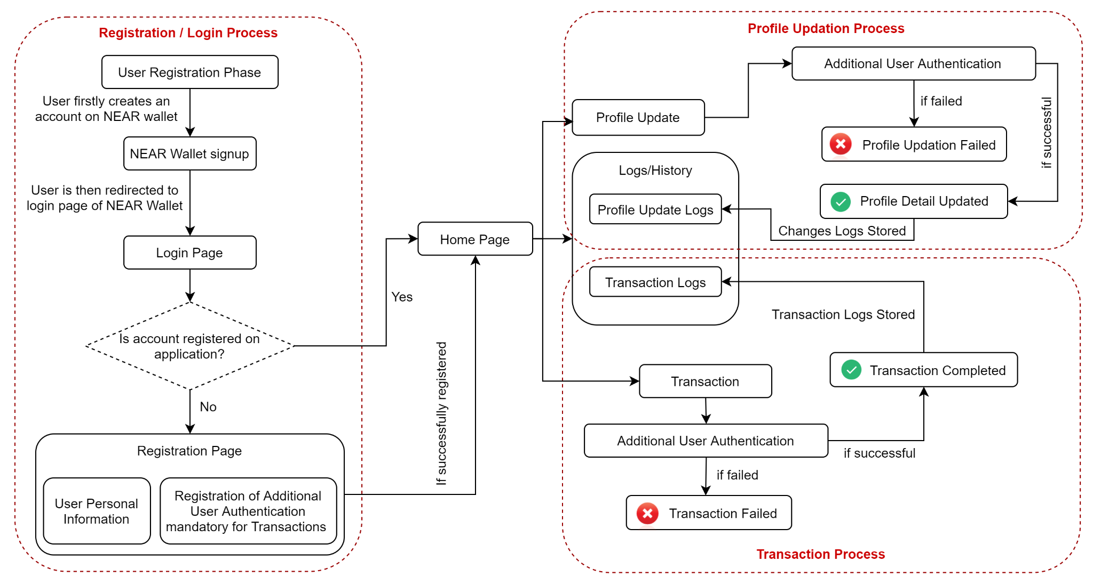

**BanQube | PAGE 09 OF 23**

* 1. **User Interface designs**

1. **Registration Page :**

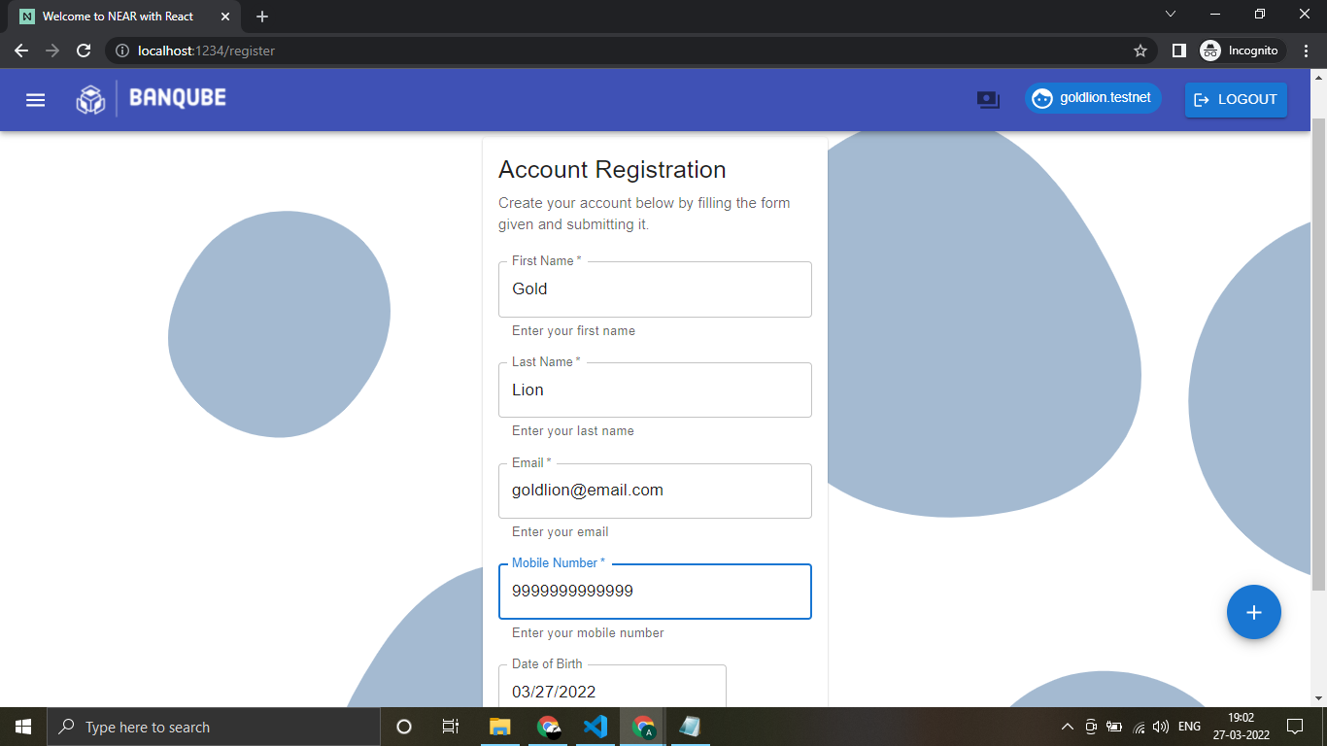

1. **Home Screen :**

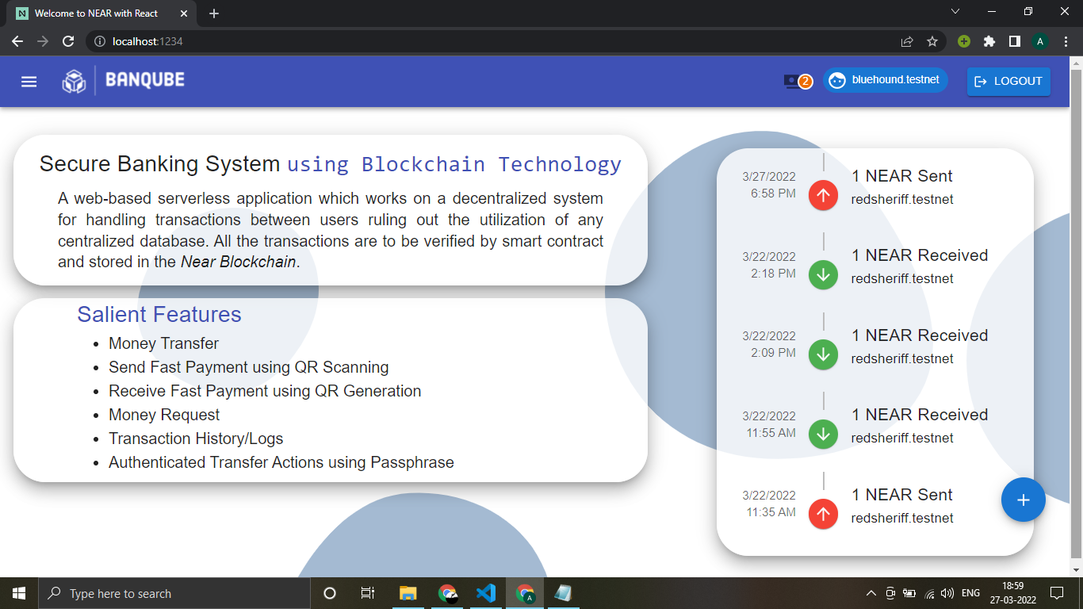

**BanQube | PAGE 10 OF 23**

1. **Money Transfer Page :**

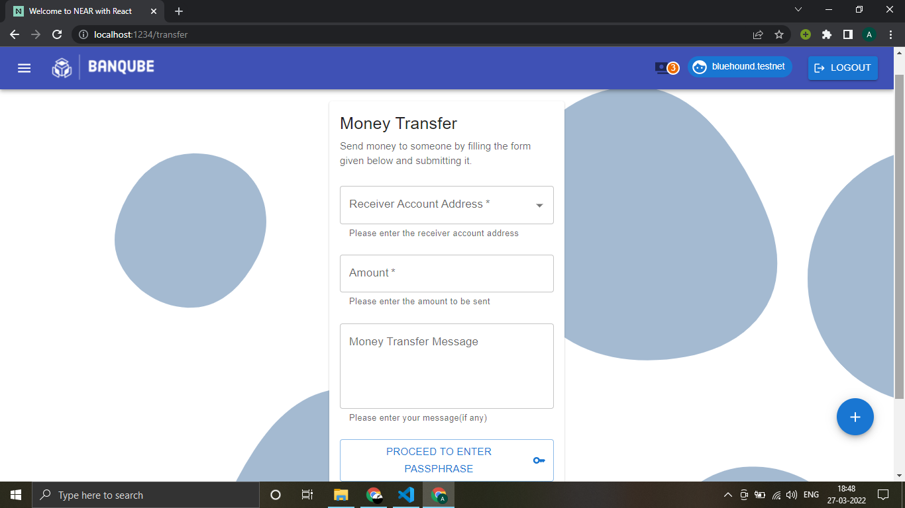

1. **Passphrase Security**

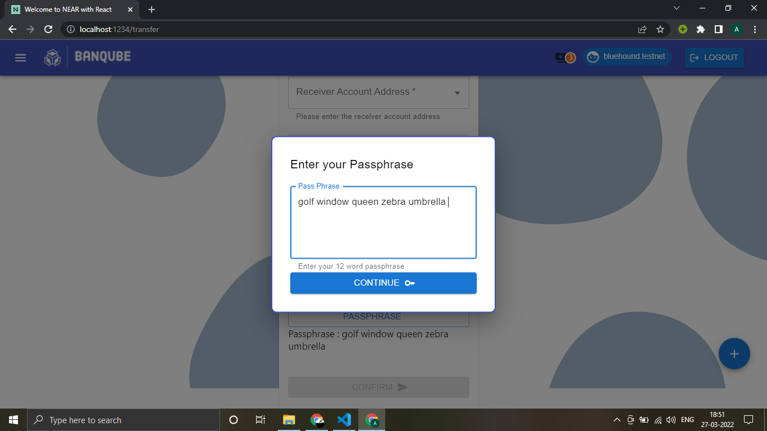

**BanQube | PAGE 11 OF 23**

1. **Receive Fast Payment through QR Generation**

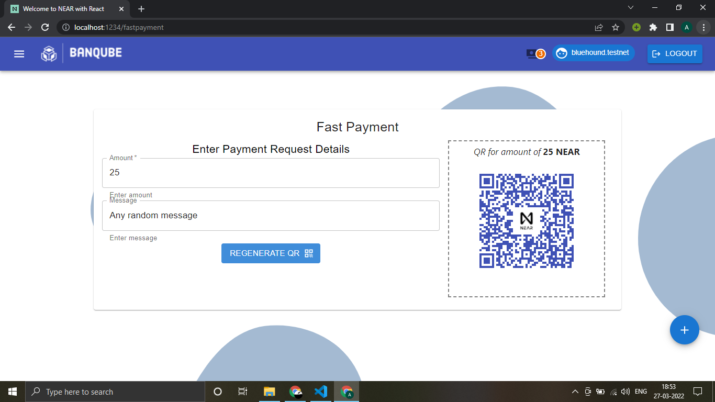

1. **Send Fast Payment through QR Scanning**

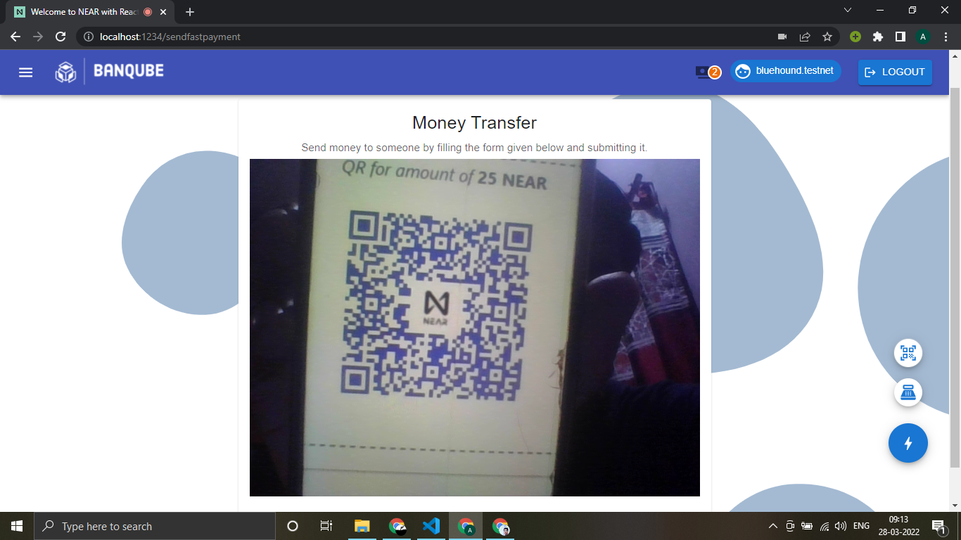

**BanQube | PAGE 12 OF 23**

1. **Form auto fill up through QR Scanning**

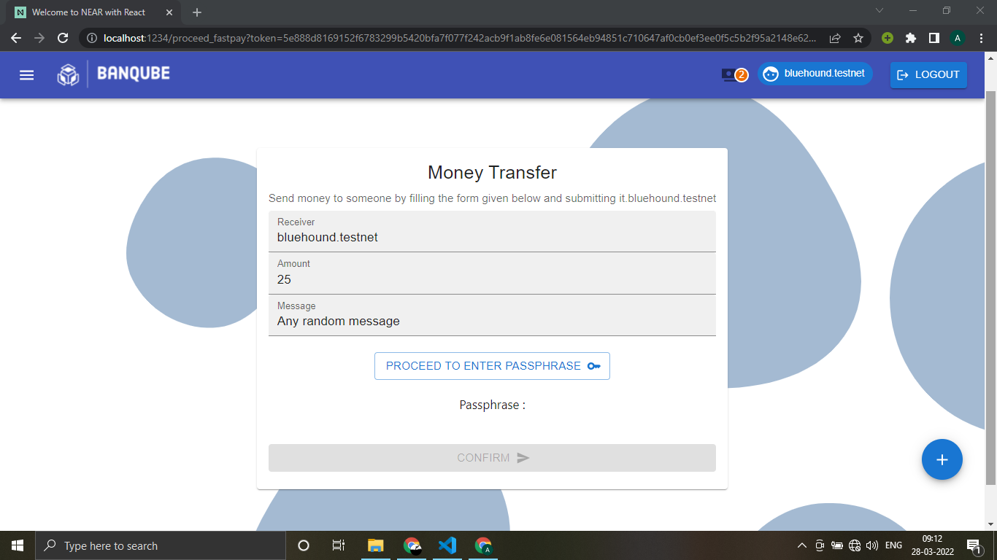

1. **Money Request**

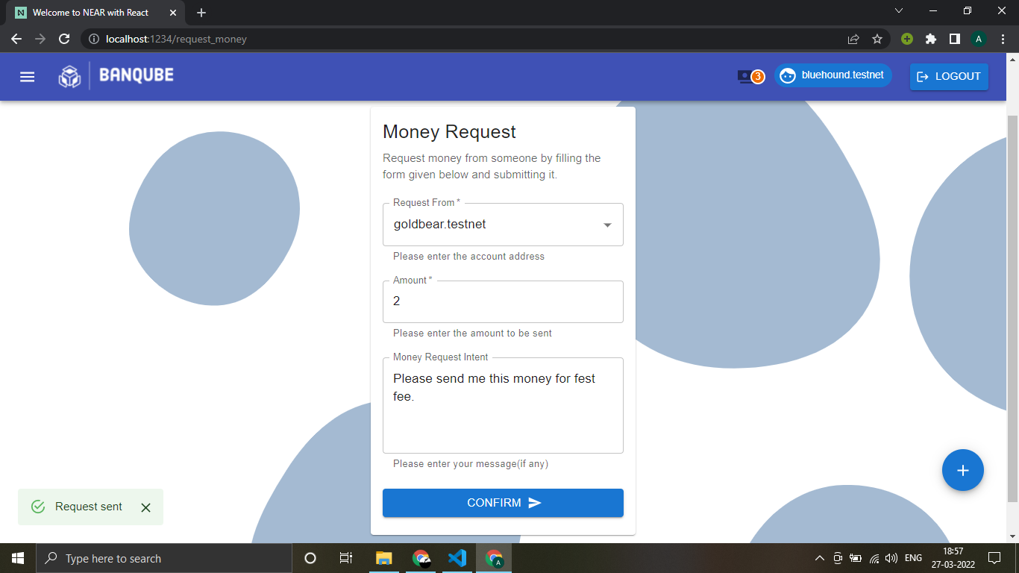

**BanQube | PAGE 13 OF 23**

1. **New Money Request Notification**

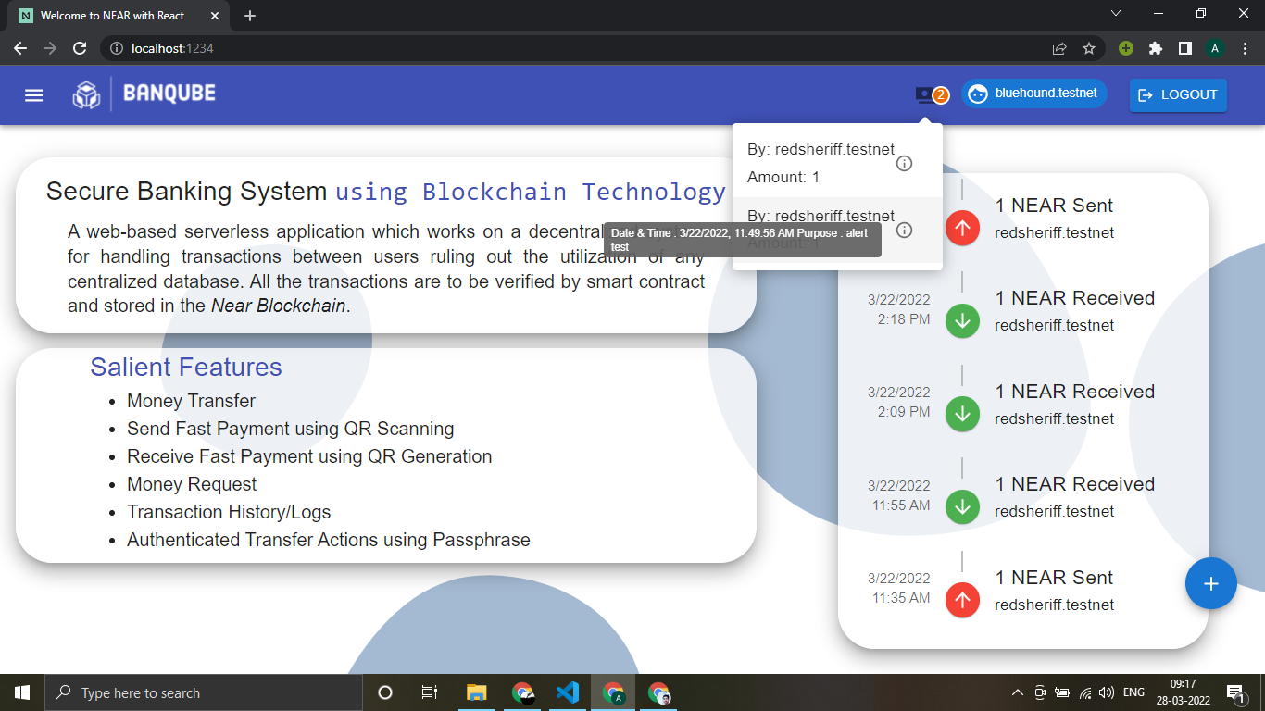

1. **Accept / Reject New Money Requests**

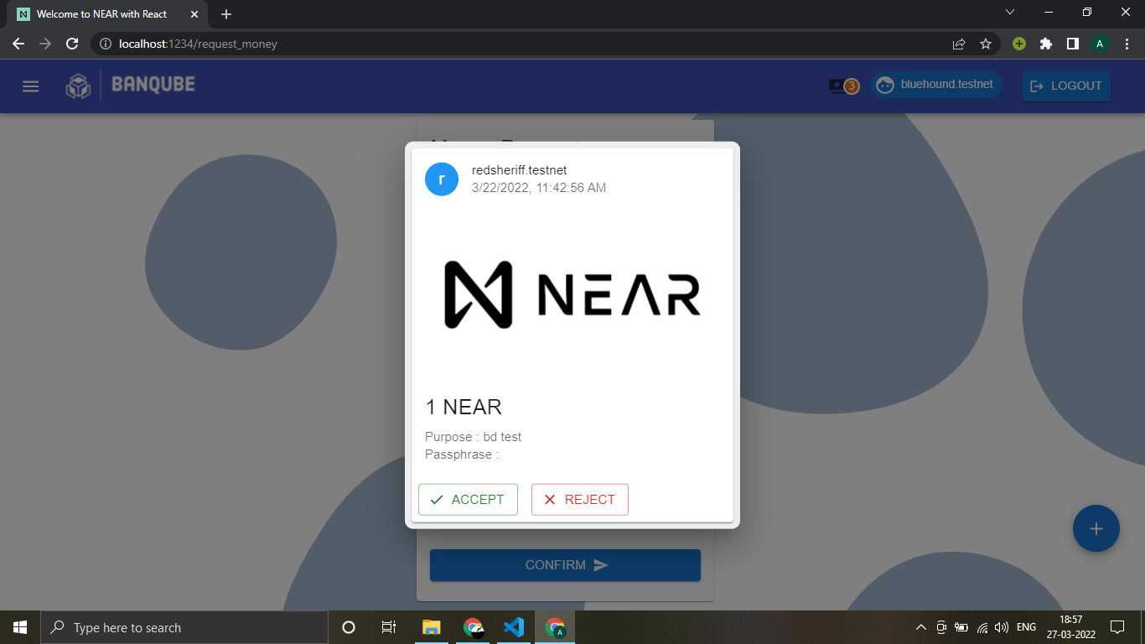

**BanQube | PAGE 14 OF 23**

1. **Recent Transactions**



1. **Transfer History**

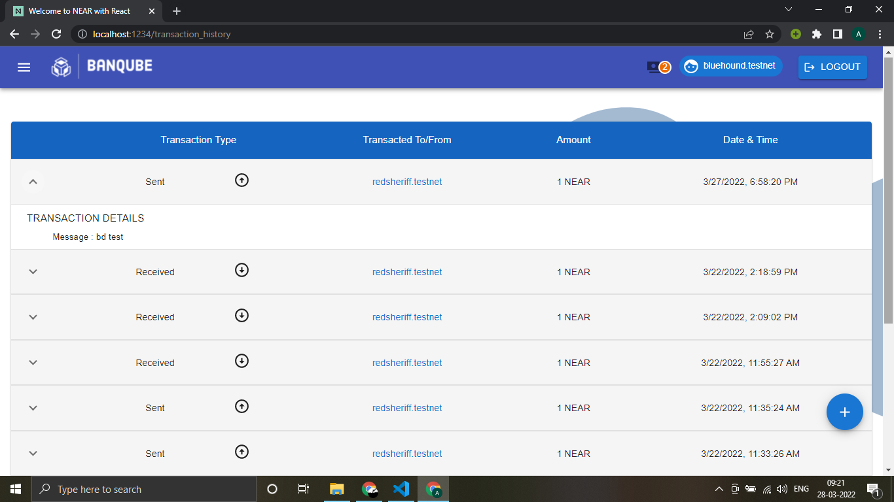

**BanQube | PAGE 15 OF 23**

1. **TECHNICAL IMPLEMENTATION & ANALYSIS**
   1. **Outline**

The project emcompasses various technical modules making the entire workflow and outline, NEAR Blockchain acts as the ledger for our transaction processes. The Registration Module serves the purpose to register new users in the network, once the user is registered they can transact tokens with other users on the network with the help of Transfer Token module. The QR module makes the process of transaction faster for the users through which they use the generated QR to send/receive payments and payment requests respectively.

* 1. **Technical coding and code solutions**

**AssemblyScript :**

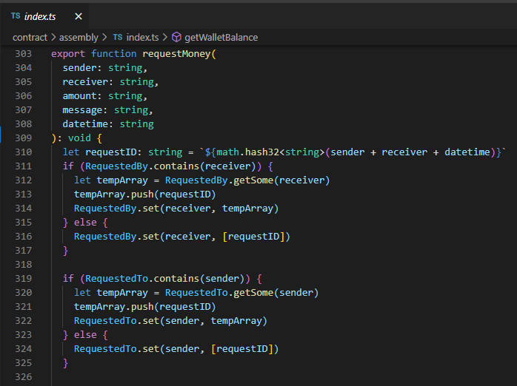

**BanQube | PAGE 16 OF 23**

**React :**

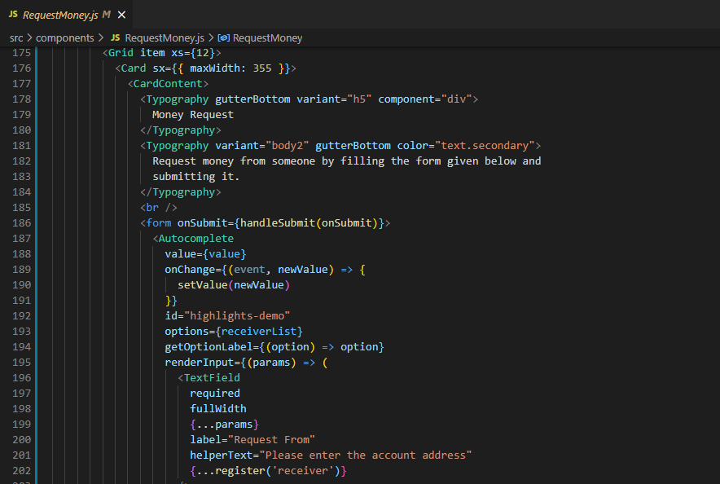

* 1. **Prototype submission**

GITHUB REPO LINK : [**Github Link**](https://github.com/thealkeshgupta/Secure-Banking-System-Using-Blockchain-Technology)

**BanQube | PAGE 17 OF 23**

* 1. **Test and validation**

1. **Wrong Amount Value**
   1. **Positive Amount**

**Correct Input :**

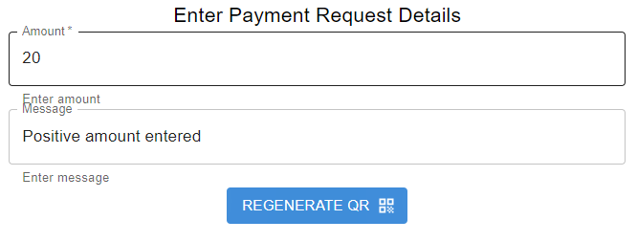

**Output :**



**BanQube | PAGE 18 OF 23**

* 1. **Negative Amount**

**Incorrect Input :**

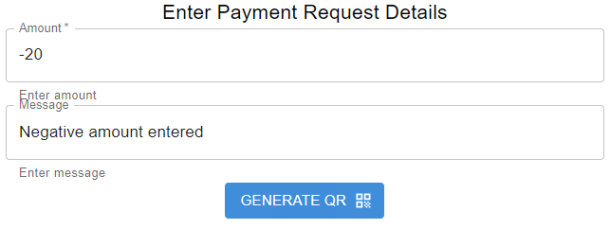

**Output :** (No output generated)

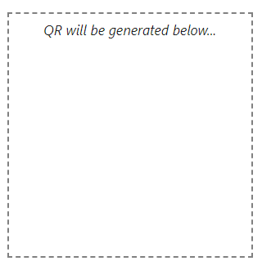

**BanQube | PAGE 19 OF 23**

1. **Passphrase Length**
   1. **12 Word Long Passphrase**

**Input : (Example)** pectioniela fowarten proationizes hoddlen convold perchery pate forminsting adowniferta winfirn lusplamao onizes

**Output :** pectioniela fowarten proationizes hoddlen convold perchery pate forminsting adowniferta winfirn lusplamao onizes

* 1. **Less than 12 Word Long Passphrase**

**Input : (Example)** roationizes pate forminsting adowniferta winfirn lusplamao onizes

**Output :** roationizes pate forminsting adowniferta winfirn lusplamao onizes (Invalid Input)

* 1. **More than 12 Word Long Passphrase**

**Input :** **(Example)** pectioniela fowarten proationizes hoddlen convold perchery pate forminsting adowniferta winfirn lusplamao onizes proationizes perchery

**Output :** pectioniela fowarten proationizes hoddlen convold perchery pate forminsting adowniferta winfirn lusplamao onizes (sliced 12 words)

**BanQube | PAGE 20 OF 23**

1. **PROJECT OUTCOME AND APPLICABILITY**
   1. **Outline**

The banking industry is transitioning from traditional securities to high-tech securities. By duplicating existing asset transactions on the blockchain, industry has begun to experiment with blockchain. In terms of infrastructure, Blockchain is open source software that enables the real-time movement of digital assets between users on a network.

* 1. **Key implementations outlines of the System**

We have taken into consideration the NEAR blockchain to implement transactions features for users that demonstrate a significant reduction in asset transfer costs and timeframes on its counterpart conventional banking system.

* 1. **Significant project outcomes**

A blockchain based banking system which works on the principle of immutable distributed ledger we aim to improve the current financial system by incorporating blockchain features in our project. By inclusion of a decentralized structure a higher security is ensured making the financial system more secure.

* 1. **Project applicability on Real-world applications**

Our project is based on blockchain and finds its applicability in the field of banking sector. The key benefits of Blockchain technology in the banking sector are that it increases efficiency, improves security, provides immutable records, allows for faster transaction times, and eliminates the need for third-party participation, lowering costs. Some of the advantages of using replacing the traditional banking system are:

1. **Faster payments:**

By offering higher security and lower cost of sending payments, banks could introduce this blockchain service to bring new products to the market.

**BanQube | PAGE 21 OF 23**

1. **Clearance and settlement systems**

A simple bank transfer needs to bypass a complicated system of intermediaries. Whereas with blockchain enables banks to keep track of all the transactions publicly and transparently.

1. **Blockchain in banking as digital identity verification**

With blockchain, consumers and companies will benefit from accelerated verification processes. Also users will be able to choose how they wish to identify themselves and with whom they agree to share their identity. They will need to register their identity on the blockchain only once.

* 1. **Inference**

The problems faced by conventional banks are huge investments that are being made to establish a system to ensure the process of transactions as per an article bybusinessworld**[5]** .But blockchain allows all the information to be stored in one location. This guarantees the dignity and non-repudiation of the stored data. It allows organizations to access the verification information of a specific customer from another organization and thus avoids duplication of data. A simple bank transfer needs to bypass a complicated system of intermediaries such as custodial services before it reaches its destination; this problem is also resolved by the inclusion of blockchain in banking services.

**BanQube | PAGE 22 OF 23**

1. **CONCLUSIONS AND RECOMMENDATION**
   1. **Limitation/Constraints of the System**

This application runs on NEAR testnet and hence needs added passphrase input for each transaction made. This constraint can be sorted out by running the application on NEAR mainnet.

* 1. **Future Enhancements**

1. Inclusion of Multi-factor authentication inorder of increase the security of the system.
2. User Validation via OTP will be implemented to verify the email and mobile number of users.
3. Email and message notification implemented to notify the user about the activity happening in the account.
   1. **Conclusion**

We were able to implement blockchain technology to develop a decentralized, distributed financial system with a transparent token exchange system whilst playing a significant role in accelerating financial inclusion by providing a fast and transparent settlement of transactions. Our system can provide a supportive ecosystem for the private and public banking sector.

We were able to properly execute NEAR token transfers across accounts, as well as their pass security. We also designed a mechanism to request tokens from other users and notify them about the same. Moreover, we also designed an easy-to-use token transfer system using QR code creation and scanning. Lastly, we provided users with an interactive user interface and complete transaction logs for its record.

**BanQube | PAGE 23 OF 23**

**REFERENCES**

1. [[Blockchain application and outlook in the banking industry, Ye Guo and Chen Liang, 2016](https://www.researchgate.net/publication/311549710_Blockchain_application_and_outlook_in_the_banking_industry)
2. [Blockchain Technology and the Financial Services Market, Krause et al., 2017](https://www.researchgate.net/publication/307599627_Blockchain_Technology_and_the_Financial_Services_Market_State-of-the-Art_Analysis)
3. [BlockChain & Financial Inclusion,Prof. Reena Aggrawal, 2017](https://digitalchamber.org/assets/blockchain-and-financial-inclusion.pdf)
4. [Blockchain in banking, Deloitte, 2017](https://www2.deloitte.com/content/dam/Deloitte/in/Documents/strategy/in-strategy-innovation-blockchain-in-banking-noexp.pdf)
5. [Block Chain Technology its use in Banking Sector-S Ravi - BW Businessworld](https://www.businessworld.in/article/Block-Chain-Technology-its-use-in-Banking-Sector/26-10-2020-335662/)